CENG 317

Progress Report (Week 12)

Software Controlled Drone (SCD)

Pramit Roy

Prof: Kristian Medri

Nov 24, 2016

Build Progress:

Sparkfun nrf24l01 hardware build complete along with newly added antenna.

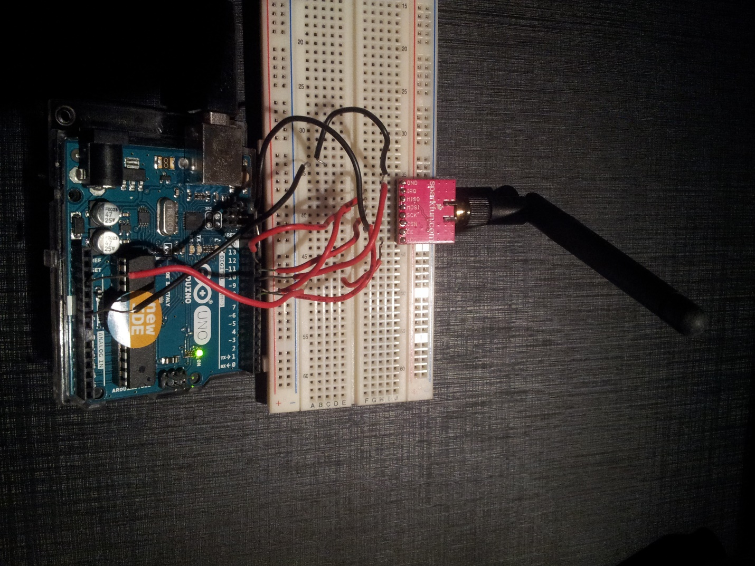

Ran a sample 2.4 GHz wifi scanner program with it to verify working hardware. This scanner scans available channels and reports interference. 0 indicates clear channels. Most channels observed appears to have no interference.

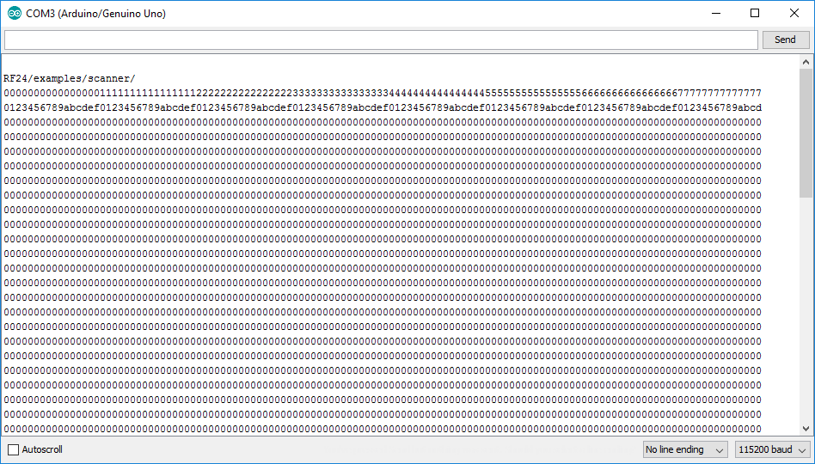

In addition to this newly provided XBee RF module is configured with XCTU.

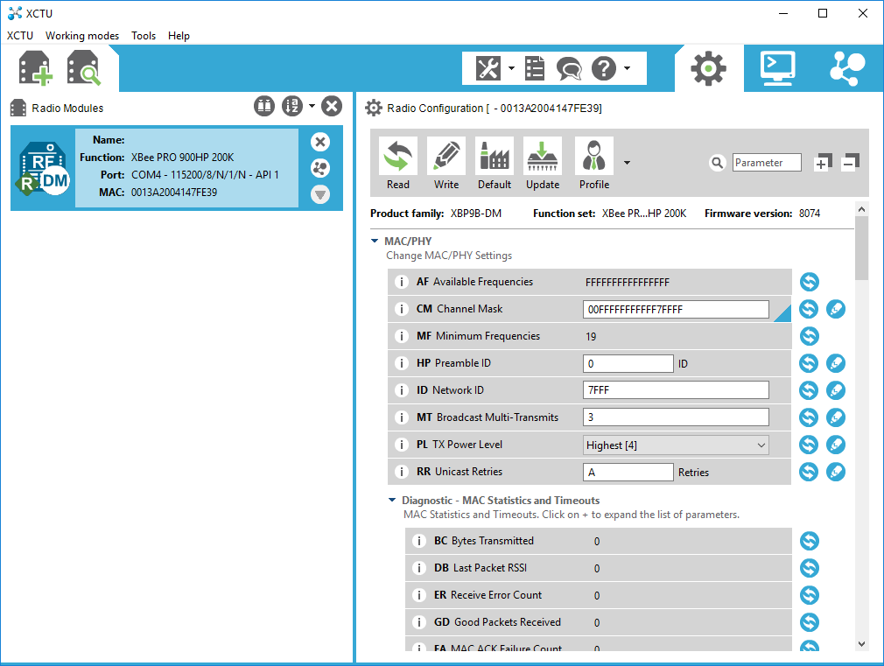

Budget:

Additional expense of $10 due to the antenna needed for the nrf24l01 module.